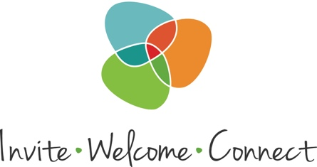

**Subject:** Our New Subscription to Invite Welcome Connect On Demand

Dear Ministry Leader:

We are thrilled to announce that the diocese is making available a subscription to Invite Welcome Connect On Demand online training materials and resources.

Guided by the gospel imperative to “Go and make disciples of all nations,” the ministry of Invite Welcome Connect equips and empowers individuals and congregations to practice evangelism, hospitality, and connectedness.

An annual subscription gives all members of a church or diocese unlimited, 24/7 access to all Invite Welcome Connect learning materials: Video workshops, checklists, downloadable documents and transcripts, quick quizzes to check your progress, tools to help generate ideas, and more being added all the time.

To access the materials, you’ll need this “coupon code”:

**[[[[ENTER YOUR COUPON CODE]]]]**

Share this code with anyone in your congregation who would like to be part of the training. There is no limit to the number of individuals who can access the training, though each individual accessing the training will need to redeem the code. The following page explains how to use the code both in and in a video:

<https://www.invitewelcomeconnect.com/post/video-how-to-activate-your-on-demand-subscription>

Anyone who has difficulty can [request help,](mailto:steve@invitewelcomeconnect.com?subject=Help%20Redeeming%20a%20Coupon%20Code) or use the "Let’s Chat" button on the Web site.

The materials have a "Before You Start the Training" section that will be very helpful to any group or individual wanting to start an Invite Welcome Connect ministry. I recommend you review it as soon as possible.

The site also has a group study guide for churches that would like to study Mary Parmer's *Invite Welcome Connect* book together. It's appropriate for a Lenten study or any time of year:

<https://www.invitewelcomeconnect.com/post/new-group-study-guide-available-for-invite-welcome-connect-book>

There is also a package of materials you can use to announce and promote the subscription among your people:

https://www.invitewelcomeconnect.com/mediakit

In the meantime, please let me know if I can answer any questions.

May you find this new resource a blessing to your ministry.