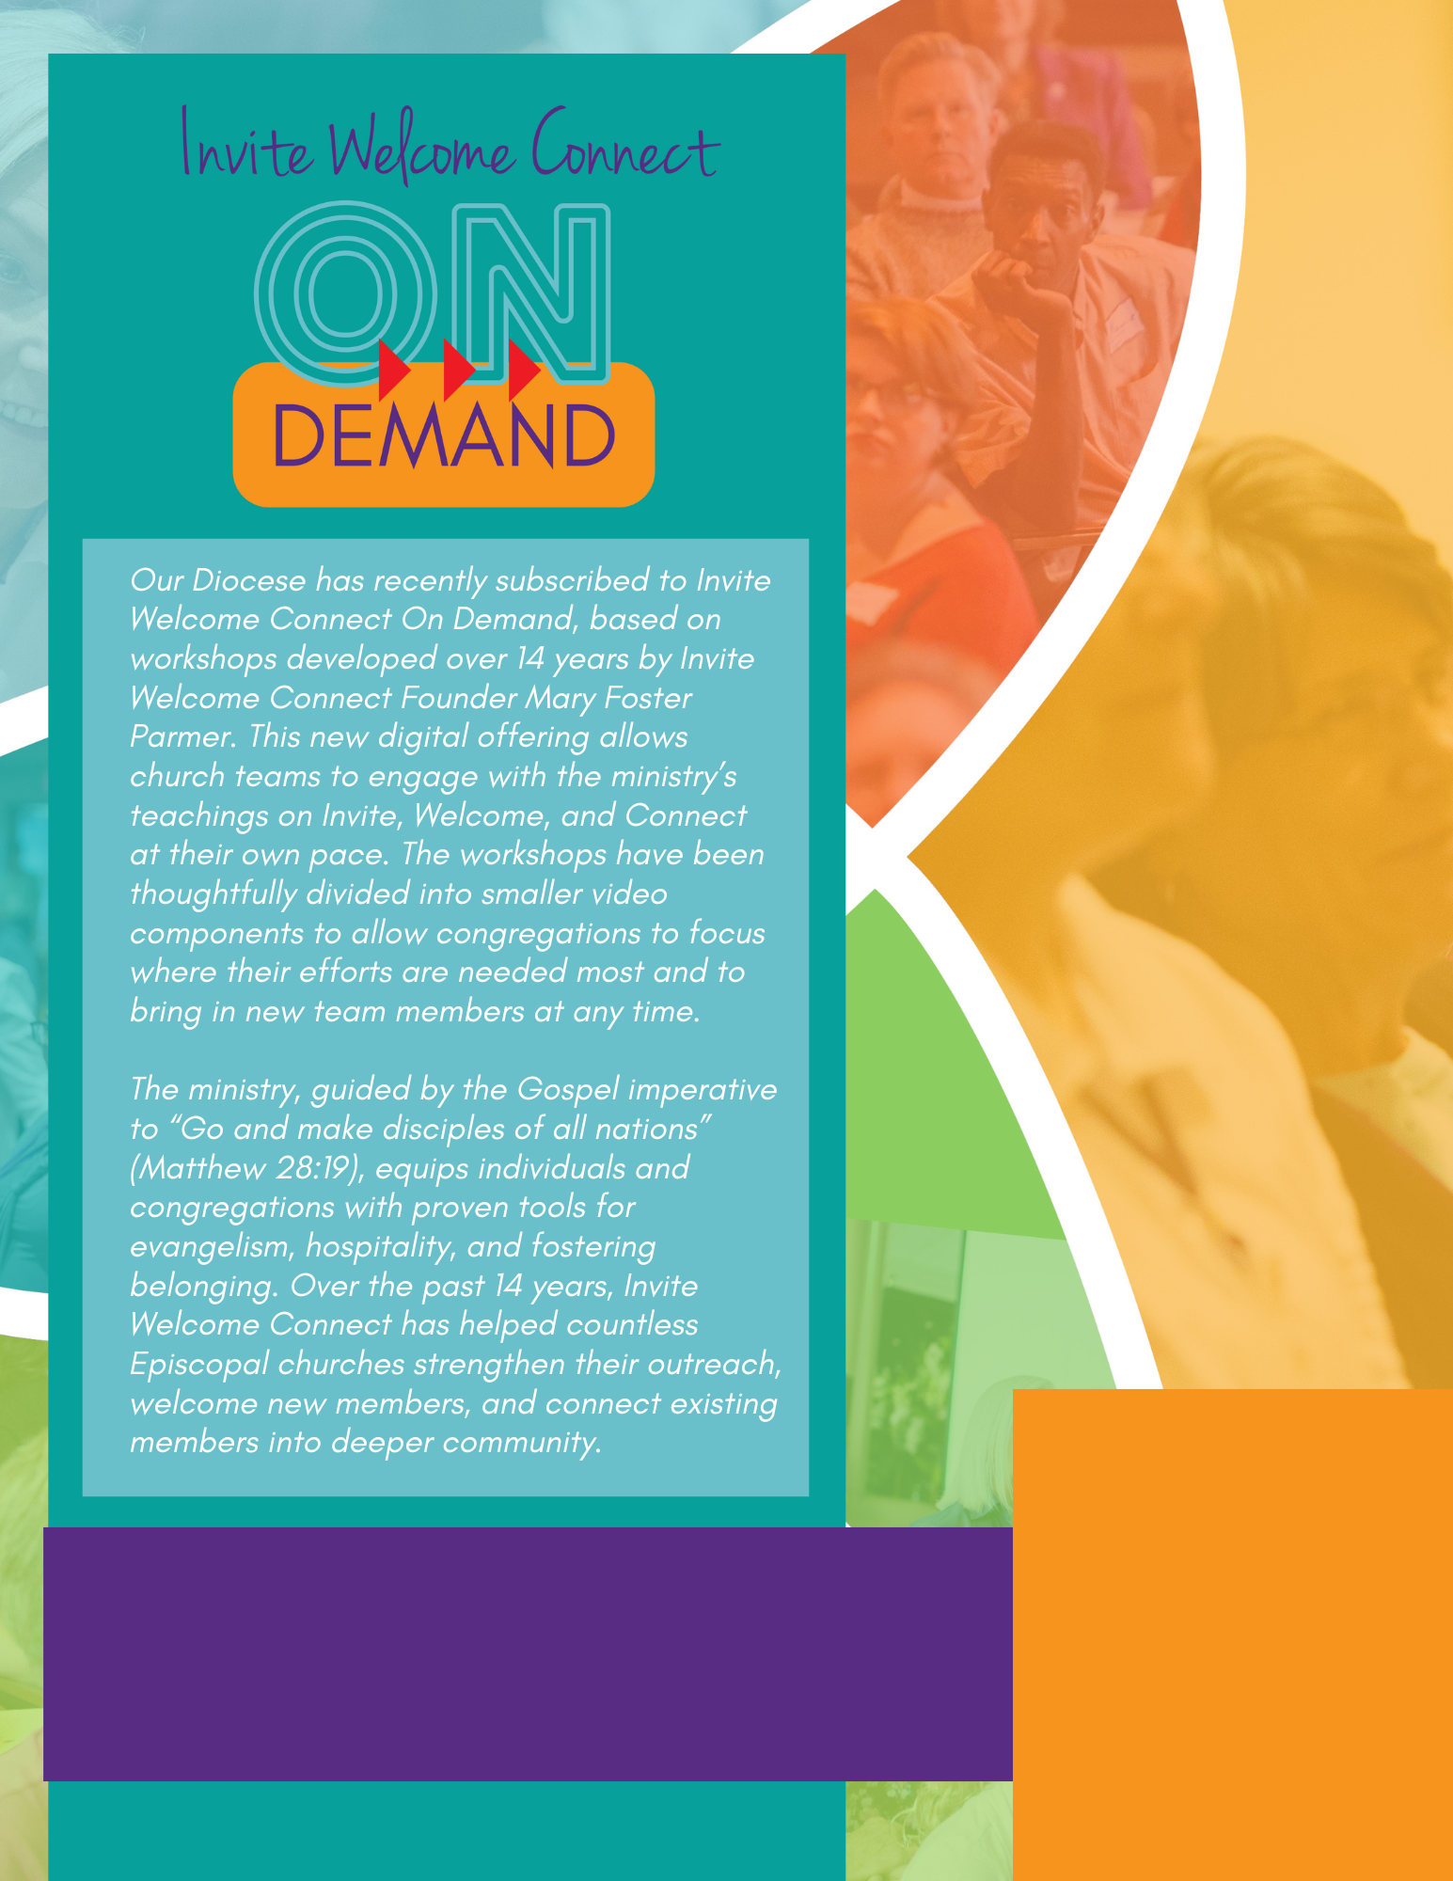



Our Diocese has recently subscribed to Invite Welcome Connect On Demand, based on workshops developed over 14 years by Invite Welcome Connect Founder Mary Foster Parmer. This new digital offering allows church teams to engage with the ministry’s teachings on Invite, Welcome, and Connect at their own pace. The workshops have been thoughtfully divided into smaller video components to allow congregations to focus where their efforts are needed most and to bring in new team members at any time.

The ministry, guided by the Gospel imperative to “Go and make disciples of all nations” (Matthew 28:19), equips individuals and congregations with proven tools for evangelism, hospitality, and fostering belonging. Over the past 14 years, Invite Welcome Connect has helped countless Episcopal churches strengthen their outreach, welcome new members, and connect existing

*members into deeper community.* More info here.

Join us to learn more! Time, Location, etc.

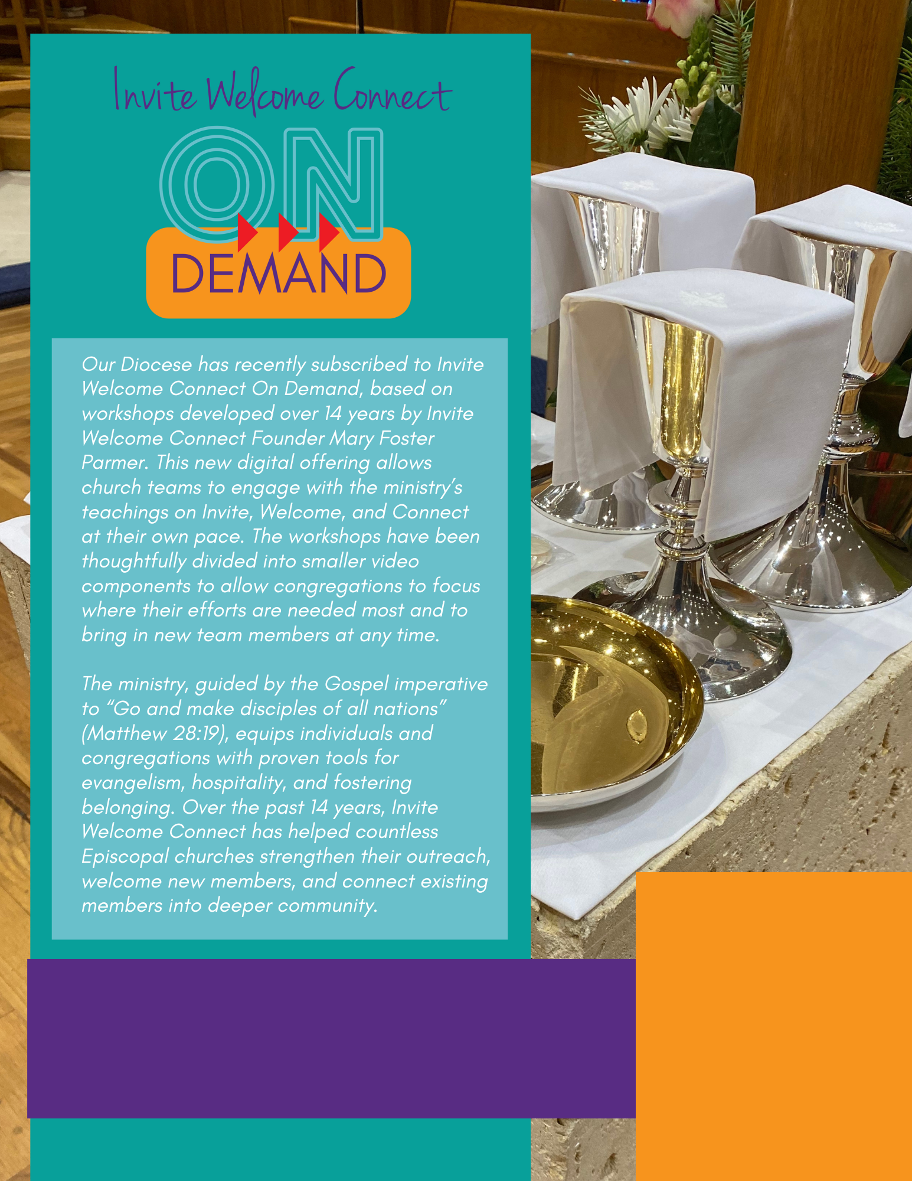

Our Diocese has recently subscribed to Invite Welcome Connect On Demand, based on workshops developed over 14 years by Invite Welcome Connect Founder Mary Foster Parmer. This new digital offering allows church teams to engage with the ministry’s teachings on Invite, Welcome, and Connect at their own pace. The workshops have been thoughtfully divided into smaller video components to allow congregations to focus where their efforts are needed most and to bring in new team members at any time.



The ministry, guided by the Gospel imperative to “Go and make disciples of all nations” (Matthew 28:19), equips individuals and congregations with proven tools for evangelism, hospitality, and fostering belonging. Over the past 14 years, Invite Welcome Connect has helped countless Episcopal churches strengthen their outreach, welcome new members, and connect existing members into deeper community.

Join us to learn more! Time, Location, etc.

More info here.

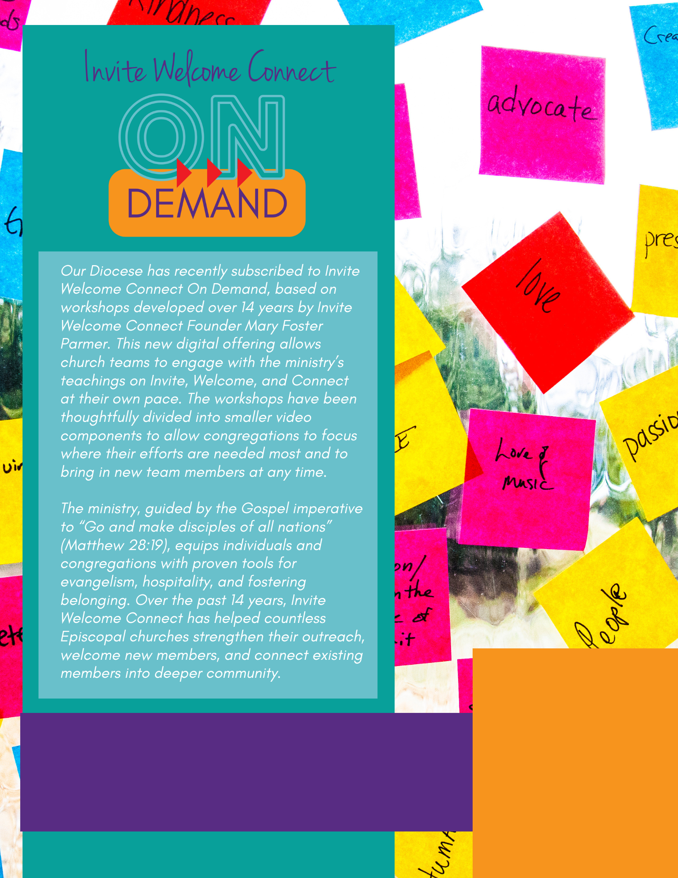

Our Diocese has recently subscribed to Invite Welcome Connect On Demand, based on workshops developed over 14 years by Invite Welcome Connect Founder Mary Foster Parmer. This new digital offering allows church teams to engage with the ministry’s teachings on Invite, Welcome, and Connect at their own pace. The workshops have been thoughtfully divided into smaller video components to allow congregations to focus where their efforts are needed most and to bring in new team members at any time.



The ministry, guided by the Gospel imperative to “Go and make disciples of all nations” (Matthew 28:19), equips individuals and congregations with proven tools for evangelism, hospitality, and fostering belonging. Over the past 14 years, Invite Welcome Connect has helped countless Episcopal churches strengthen their outreach, welcome new members, and connect existing members into deeper community.

Join us to learn more! Time, Location, etc.

More info here.